Level #1 - Automation Challenges for SDETs / Automation Testers

Automation Challenge 1:

Calculate the Total Amount of Money Spent via Playwright Script

- Open the https://demo.applitools.com
- Enter the Username as Admin and Password as Password@123
- Verify that you are on the app.html page afterward.
- Calculate the total amount spent this month.
- Create a util which will parse and check for spent vs earned.
- Verify total is 1996.22

Automation Table Challenge #1 - Watch Video
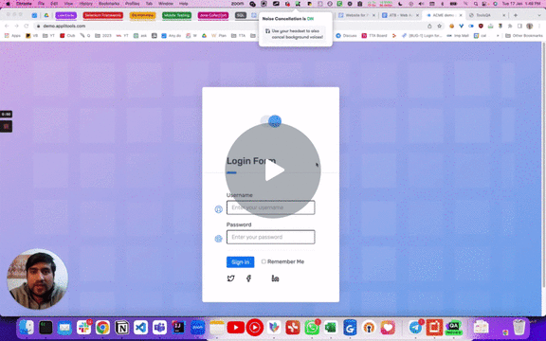

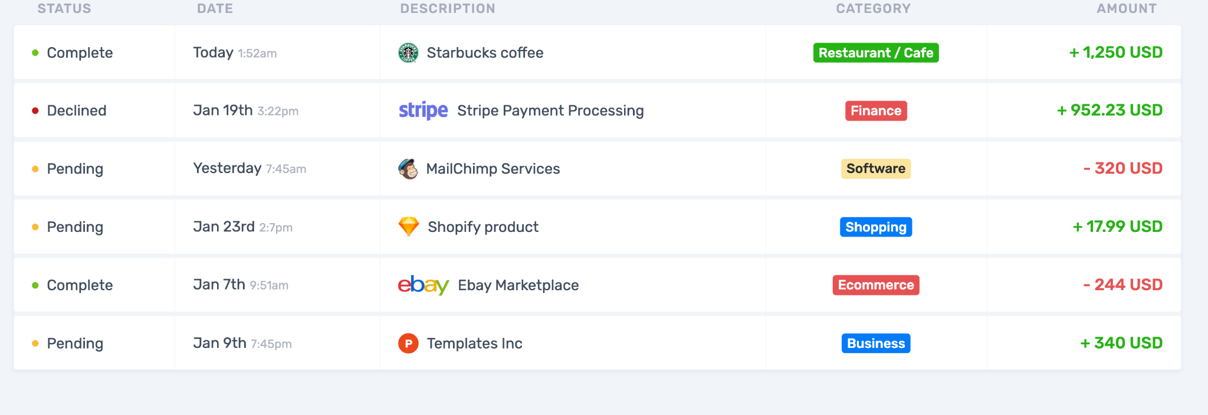

Automation Challenge 2:
Web tables verification

- Navigate to the Web Tables - Pgae - https://demoqa.com/webtables
- Click on the 3rd edit button
- 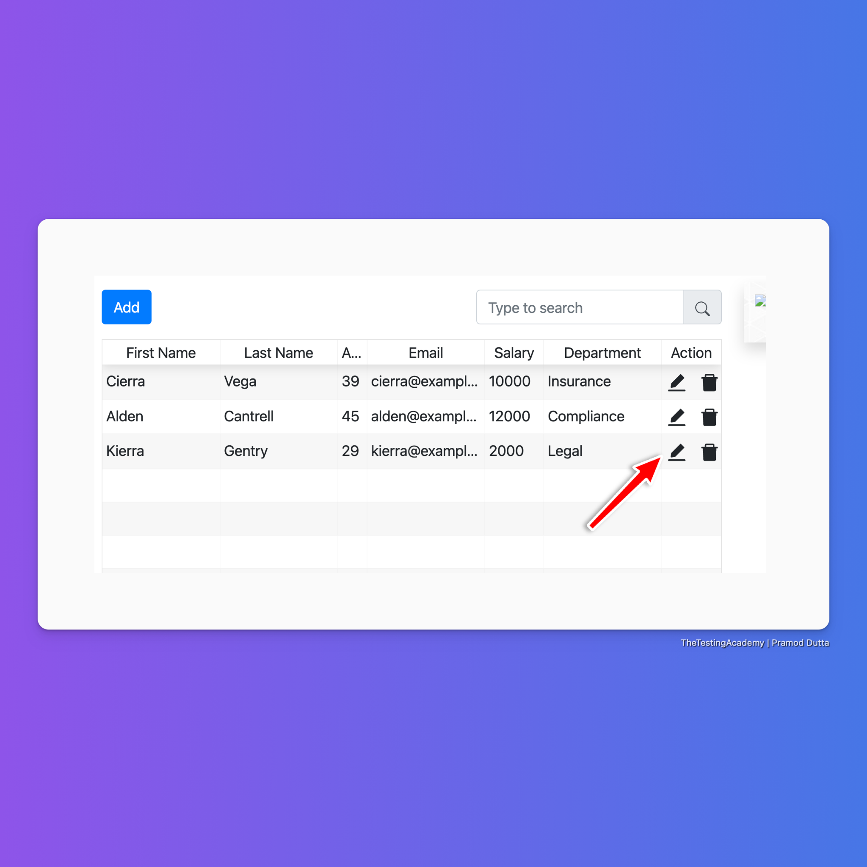
- Click on the Add and Add a new Row and verify in table.
- 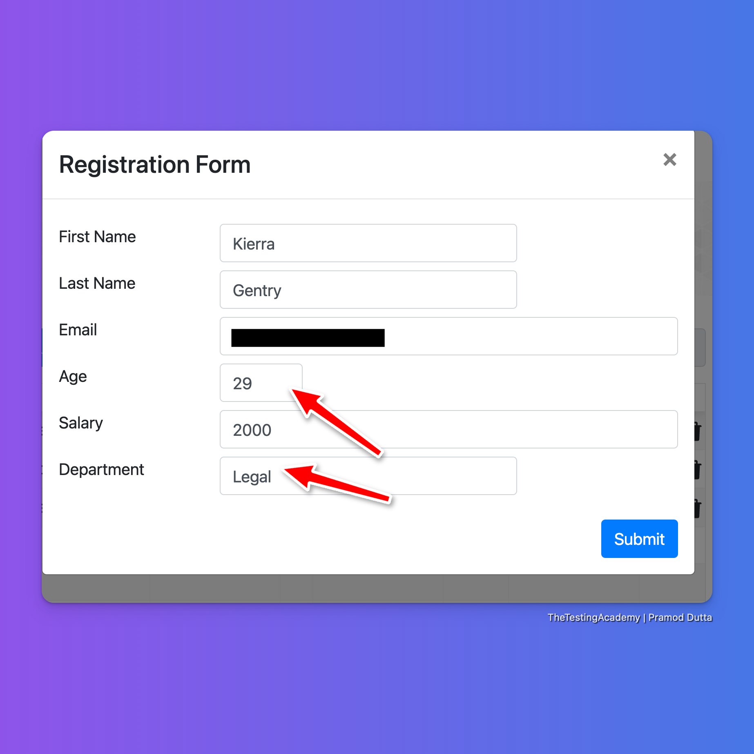
- Verify the details.
- Try to create a generic locator so that it won't break if we add new rows.

Automation Challenge 3
- Verify the content of the Model
- https://demoqa.com/modal-dialogs
- 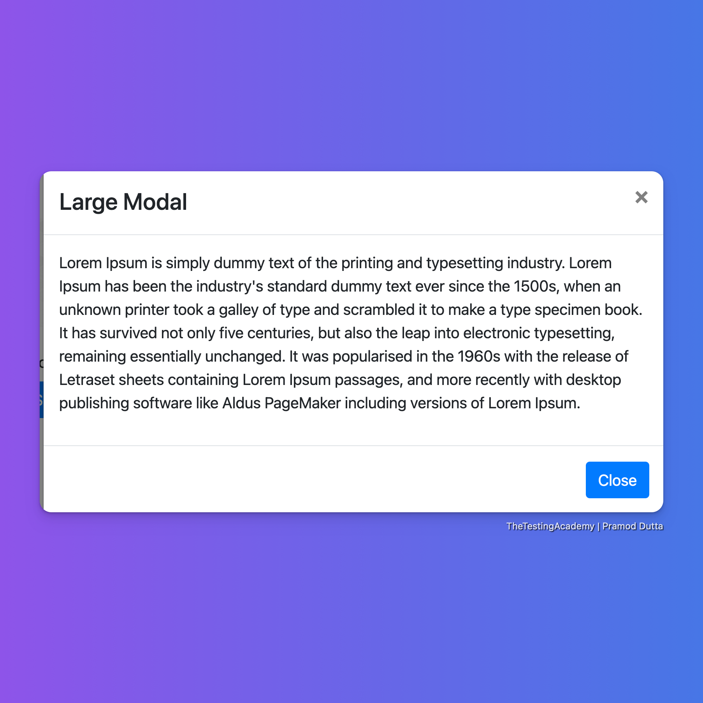

Automation Challenge 4:
Login and Dashboard Page Automation in App.vwo.com and Run in two browsers parallel.

- Open the URL https://app.wingify.com/#/login
- Enter the Username as r97ain68@1sec.email and Password as Password@123
- Verify that after you log in dashboard is visible Validate whether User is displayed in left panel and by clicking that and selecting Logout, the application is logout and user is navigated back to login page successfully.
- Run them in multiple browsers side by side and check if you can run them parallel.

Automation Login Challenge #2 - Watch Video


